

*java iot developer Lab*

Lab -1

**SUBMITTED BY: SUBMITTED TO:**

**AYUSH KUMAR JHA SURBHI SARASWAT Ma’am**

**SAP ID - 500086400**

**Enrollment no - R200220083**

**B.C.A -I.O.T.**

Questions :-

1. Read in a,b, c and use the quadratic formula to calculate roots of the quadratic equation. Printsall real solutions or display a message stating that there are no real solutions. Also, calculate timetaken for executing the code.

Sol.  
import java.util.*;  
public class Question1 {  
 public void display(long end , long start) {  
 System.*out*.printf("Calculating Method execution time: %d Nanoseconds",(end - start));  
 }  
 public void process(int a, int b, int c){  
 int d,f=0;  
 d=(b*b)-(4*a*c);  
 if(d==0)  
 {  
 System.*out*.println("Roots are real and Equal");  
 f=1;  
 }  
 else if(d>0)  
 {  
 System.*out*.println("Roots are real and UnEqual");  
 f=1;  
 }  
 else  
 System.*out*.println("Roots are imaginary");  
 if(f==1)  
 {  
 float r1=(float)(-b+Math.*sqrt*(d))/(2*a);  
 float r2=(float) (-b-Math.*sqrt*(d))/(2*a);  
 System.*out*.println("Roots are : "+r1+" ,"+r2);  
 }  
  
 }

public static void main(String args[]  
 )  
 {  
 int a,b,c,d,f=0;  
 Scanner scr=new Scanner(System.*in*);  
 System.*out*.println("\nEnter the values of a ,b ,c : ");  
 a=scr.nextInt();  
 b=scr.nextInt();  
 c=scr.nextInt();  
  
 long start = System.*nanoTime*();

Question1 obj = new Question1();  
 obj.process(a,b,c);  
 long end = System.*nanoTime*();  
 obj.display(end, start);  
 }  
}

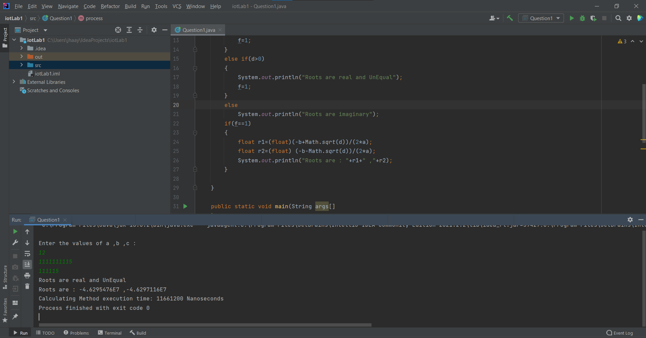

1. . Read the order and elements of two 2-D matrices. Calculate the multiplication of those twomatrices. Also, calculate time taken for executing the code.

Sol.  
import java.util.Scanner;  
public class Question2 {  
 public void display(long end , long start) {  
 System.*out*.printf("Calculating Method execution time: %d Nanoseconds",(end - start));  
 }  
  
 public static void main(String args[]) {  
 int n;  
 Scanner input = new Scanner(System.*in*);  
 System.*out*.println("Enter the number of rows and columns of the matrices. They must be equal.");  
 n = input.nextInt();  
 int[][] a = new int[n][n];  
 int[][] b = new int[n][n];  
 int[][] c = new int[n][n];  
 System.*out*.println("Enter the numbers of the first matrix. Numbers will be added row wise \n");  
 for (int i = 0; i < n; i++)  
 {  
 for (int j = 0; j < n; j++)  
 {  
 a[i][j] = input.nextInt();  
 }  
 }  
 System.*out*.println("Enter the numbers of the Second matrix. Numbers will be added row wise. \n");  
 for (int i = 0; i < n; i++)  
 {  
 for (int j = 0; j < n; j++)  
 {  
 b[i][j] = input.nextInt();  
 }  
 }  
 long start = System.*nanoTime*();  
 System.*out*.println("Generating the multiplication of matrices.....");  
 for (int i = 0; i < n; i++)  
 {  
 for (int j = 0; j < n; j++)  
 {  
 for (int k = 0; k < n; k++)  
 {  
 c[i][j] = c[i][j] + a[i][k] * b[k][j];  
 }  
 }  
 }

System.*out*.println("The product of the matrices is shown as below");  
 for (int i = 0; i < n; i++)  
 {  
 for (int j = 0; j < n; j++)  
 {  
 System.*out*.print(c[i][j] + " ");  
 }  
 System.*out*.println();  
 }  
 input.close();  
 Question2 obj = new Question2();  
  
 long end = System.*nanoTime*();  
 obj.display(end , start);  
 }  
}

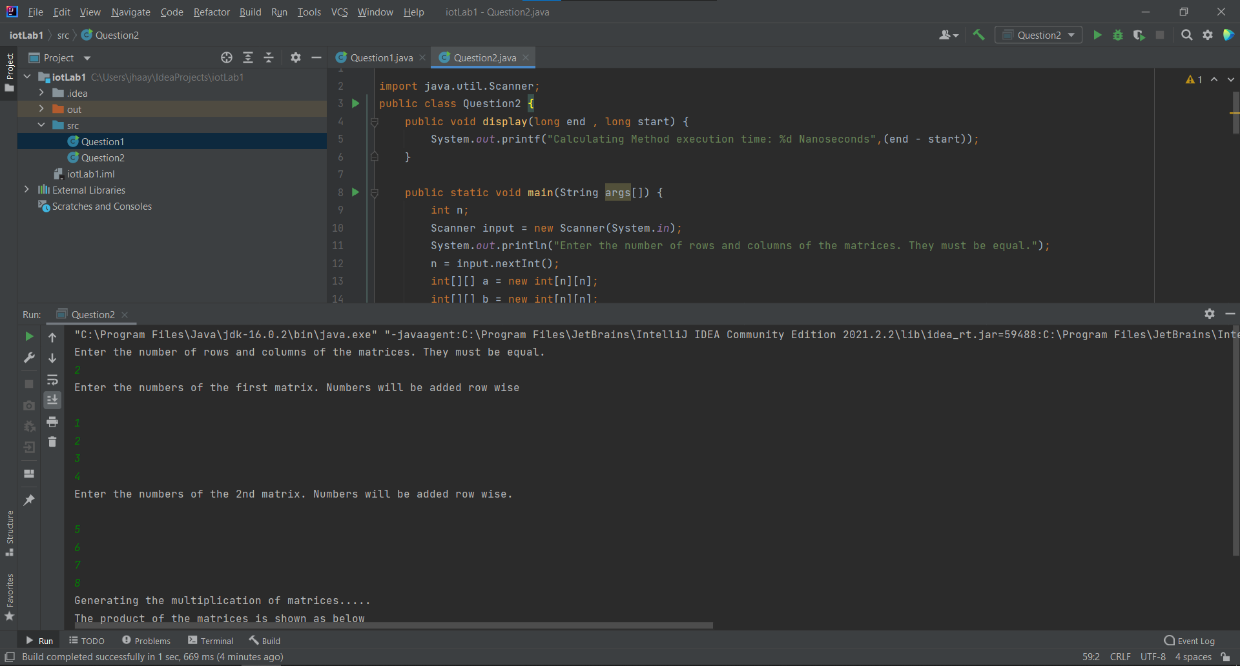

1. Write a java program to implement method overloading, method overriding, and constructorsoverloading.

Sol.

class ForQuestion{  
 int number1;  
 String value;  
  
 ForQuestion(){  
 this.number1= 10;  
 this.value="String One";  
 }  
 // Constructor Overloading  
  
 ForQuestion(int num , String val){  
 this.number1= num;  
 this.value=val;  
 }  
 void result (){  
 System.*out*.printf("The Integer value %d and String Value is %s.\n",number1,value);  
 }  
 void method(){  
 System.*out*.println("A normal method that prints");  
 }  
 // Method Overloading  
 void method(int a){  
 this.number1= a;  
 System.*out*.println("Now, This is a case of method Overloading");  
 }  
}  
  
class ForOverriding extends ForQuestion{  
 // Method Overriding  
 void method(int a){  
 this.number1= a;  
 System.*out*.println("Now, This is a case of method Overriding");  
 }  
 void result(){  
 super.result();  
 System.*out*.println("The End");  
 }  
}  
  
public class Question3 {  
 public static void main(String[] args) {  
 ForQuestion obj1 = new ForQuestion();  
 int num = 20;  
 String val ="String Two";  
 ForQuestion obj2 = new ForQuestion(num , val);  
  
 obj1.result();  
 obj2.result();  
  
 obj1.method();  
 obj1.result();  
  
 obj1.method(100);  
 obj1.result();  
  
 ForOverriding obj3 = new ForOverriding();  
 obj3.method(150);  
 obj3.result();  
  
 }  
}

